TEMPLATE INSTRUCTIONS
This template document contains guidance notes, such as this one. These instructions should therefore be deleted before the release of the document. This also applies to this chapter "Template instructions". Information highlighted in yellow should also be evaluated and completed.
Sections that are indicated as optional can be deleted. Also, required content can be added.
The version history below applies to the template and not to the resulting document. Clean up the table as needed and use it for your document control purposes.
Template Version History
Version | Date of validity | Author | Description of change
1 | 2022-04-05 | Célia Cruz | First version
2 | 2022-06-29 | Célia Cruz | Review formatting. Review consistency of referenced documents. Addition subsections Review of requirements related to product & Preservation of product

Version History
Version | Date of validity | Created by | Approved by | Description of change
1 | YYYY-MM-DD | [Name, including digital signature] | [Name, including digital signature] | First version

Purpose and Scope
The purpose of this procedure is to describe methods for software development that allow a secure development of the specified quality and in conformity with regulatory and normative requirements (including IEC 62304).
This procedure applies to all software development activities for software that qualified as a medical device, regardless of whether they are for initial development or maintenance of existing software applications.

Responsibilities
Please adapt the responsibilities accordingly to your company.
The responsibility for the further development of this procedure is of the process owner, the CTO / head of software development. Employees in software development are responsible for compliance with this procedure.

Roles
Please adapt the roles and responsibilities accordingly to your company.
Role | Expertise and Tasks
Project Manager | - Assessment of time and effort  - Organization, Administration
Product Manager / Product owner | Requirements Engineering
Scrum Master | Compliance with the Scrum process
Risk Manager | - Risk Analysis  - Moderation  - Regulatory Requirements for Risk Management
Requirements Engineer | - Stakeholder Analysis  - Requirements Analysis
Usability Engineer | - Interaction Design  - UI design  - Verification and validation of usability  - Regulatory requirements on usability
Software Architect | - Software architecture, modeling, documentation  - Technologies, trends, tools  - Software engineering, best practices  - Estimation of time and effort
Software Developer | - Technologies  - Programming  - Software development, algorithms  - Unit testing  - Programming best practices
Scrum Team Member:  Community of  - Product Owner  - Scrum Master  - Risk Manager  - Software developers  - Architect  - Tester | Estimation of effort (story points)
Software tester | - Definition of black-box testing methods and strategies  - Selection and configuration of test tools  - Execution and documentation of tests
Quality and Regulatory Affairs Manager | - Verification of conformity with laws, standards, guidelines  - Quality management and document control
Hotline / Customer Support | - Requirements engineering  - feedback

Procedure
Please adapt the responsibilities and work methodologies accordingly to your company. The procedure below is an example focused on SCRUM and Agile methodologies.

Review of requirements related to product
Prior to the organization’s commitment to supply product to the customer, a review of the requirements should be performed, that include:
- product requirements are defined and documented;
- contract or order requirements differing from those previously expressed are resolved;
- applicable regulatory requirements are met;
- user training needed is identified to ensure specified performance and safe use of the medical device;
- the organization has the ability to meet the defined requirements.
Records of the results of the review and actions arising from the review shall be maintained
When product requirements are changed, the organization shall ensure that relevant documents are amended and that relevant personnel are made aware of the changed requirements.

Iterative and incremental development

General considerations
The development is performed using agile development to reduce complexity and quickly learn from mistakes and eliminate them quickly. SCRUM is used as a project model.

Sprints
Sprints are used for iterative and incremental development. Each sprint is planned individually during sprint planning.
Each sprint must be between 5 and 40 days, where the default is 30 days.
For sprint planning we use JIRA. Every sprint starts with sprint planning, divided into sprint planning 1 and 2:
- Planning 1: determining which elements of the long-term plan (product backlog) are addressed in the next sprint. The following persons should participate: Product Owner, Scrum Master, the team, optionally the project manager and / or a representative of the user.
- Planning 2: the detailed plan (sprint backlog) is understandable for all participants and individual elements of the sprint backlog (tasks) have been assigned to the team. All team members are present at the planning stage 2.
Note: Software development planning requires to be documented but sprint planning is not required to be documented.
Each sprint should provide a result as complete as possible (e.g., approved software requirement specification).
Each sprint should end with a retrospective (meeting) to ensure the results and experiences as well as improve the work for the following sprints. A sprint review should be performed to verify the successful processing of the sprint backlog.
Rough software requirement specifications are in the form of Epics and a course architecture. The software requirements are refined during sprint planning as user stories per sprint and iterated through the different phases of the sprint.
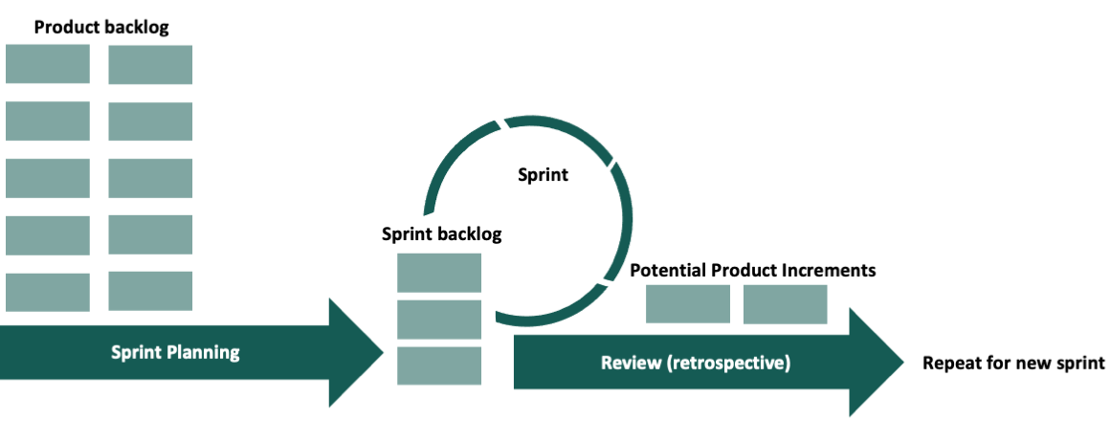

Sprint reviews
Sprint Reviews are meetings at the end of the respective sprint. The Sprint Backlog is verified to understand if it has been successfully processed. Unfinished tasks can lead to a change to the Product Backlog and / or input to the next sprint's Sprint Backlog. Sprint reviews are documented in JIRA.
The sprints after creating the coarse architecture and the sprints with every software release to be delivered require a design assessment.
The project manager can schedule or request additional design reviews in the TMP-SW-02 Software Development Plan.

Design reviews
In design reviews, the overall development is evaluated. Typical questions such as the ones below are answered:
- Have we identified the right requirements for our customers?
- Are the (past) development results suitable for fulfilling the requirements?
- Is the product designed such that it can be produced without problems?
- Are the risks consistently analyzed, known to the parties involved, and are suitable measures implemented?
- Is the project on track? Is it on time?
- Are all documents created that are required for this project to progress?
Design reviews must be documented with FRM-SW-08 Design Review. Additional design reviews are only to be documented if major design decisions have been made.
Outputs from design reviews are:
- Input for refinement of the product backlog,
- Sprint backlog (in the case the Sprint backlog was not fully executed),
- Lessons learned and improvement measures,
- FRM-SW-08 Design Review.

Software Development

Overview
The software development process is based on an iterative/agile approach. The process below allows steps backwards and iterative and incremental development.
Please adapt this figure according to your software development approach.
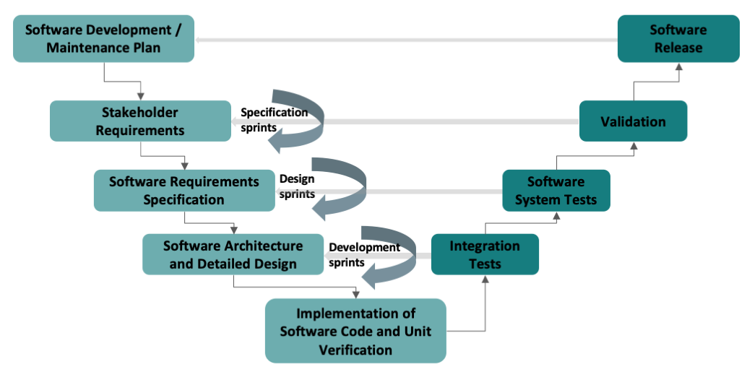

Development, maintenance, and configuration management plan
The development/maintenance plan is used to define roles, the expected software artifacts, the corresponding timelines, and any product-specific additions or changes to the procedure as described in this procedure.
In the case of software maintenance, the signed maintenance plan corresponds to a change request approval.

Inputs to the development/maintenance plan are:
- TMP-IU-01 Intended use,
- TMP-SW-02 Software Development Plan,
- Tickets/issues/items to be included in a new release/product backlog,
- Approved change request unless it is an integral part of the development plan.
The development or maintenance plan includes:
You can also optionally include the cost of development and assignment of tickets/issues/items to an individual software development.
- Assignment of team members to roles,
- Project/milestone plan with due date and results (e.g., Gantt chart, rough sprint planning),
- Planned development phases, the verification, validation, and design transfer activities, and the intended phase-dependent design reviews,
- Deviations/changes to this procedure,
- Applicable interfaces between the development processes and, e.g., risk management, usability, clinical/performance evaluation, IT security, configuration management, change management, coordination of software and system development, computerized system validation, machine learning, etc.,
- Deviations from the standard configuration management, feedback, problem-solving, and traceability process,
- For software maintenance, product backlog items that are included in the release,
- Planned version number and planned release date of the software.
The development/maintenance plan should be kept up to date.
The configuration management plan is included in the software development/maintenance plan TMP-SW-02 Software Development Plan. The software verification and integration activities in the software development plan are also included in the TMP-SW-02 Software Development Plan, unless stated otherwise.
Outputs of the development/maintenance plan are:
- Signed development/maintenance plan TMP-SW-02 Software Development Plan. The maintenance plan includes the change approval,
- List of the tickets/issues/items to be considered in the next release.

Stakeholder requirements
The stakeholder requirements should include:
- requirements specified by the customer, including the requirements for delivery and post-delivery activities;
- requirements not stated by the customer but necessary for specified or intended use, as known;
- applicable regulatory requirements related to the product;
- any user training needed to ensure specified performance and safe use of the medical device;
- any additional requirements.

For software maintenance, identification of stakeholder requirements may be skipped, as it has already been identified.
Inputs to this step are:
- TMP-IU-01 Intended use,
- TMP-IU-02 Stakeholder Requirements,
- TMP-RM-01 Risk Management File,
- FRM-SW-08 Design Review (template).
Stakeholder requirements are identified by following the steps:
- Identification of relevant stakeholders and definition of user groups (TMP-HF-01 Usability Engineering File),
- Description of core tasks (TMP-HF-01 Usability Engineering File) through for example context interviews,
- Identify stakeholder requirements, which can fit within different categories such as User requirements, Regulatory requirements, Market requirements, Organizational requirements,
- Verify stakeholder requirements.
Outputs to this step are:
- TMP-IU-02 Stakeholder Requirements,
- TMP-IU-01 Intended use (updated if needed),
- TMP-RM-01 Risk Management File,
- FRM-SW-08 Design Review.

Software requirements
Inputs to software requirements are:
- TMP-IU-01 Intended use,
- TMP-IU-02 Stakeholder Requirements,
- TMP-HF-01 Usability Engineering File,
- TMP-RM-01 Risk Management File,
- State of the art analysis,
- TMP-SW-04 Software Requirements Specification,
- TMP-SW-02 Software Development Plan,
- FRM-SW-08 Design Review (partially completed).

Software requirements are defined by following the steps:
- Description of use scenarios, according to TMP-HF-01 Usability Engineering File,
- Description of the software as a black box, particularly as applicable:
  - inputs and outputs of the software system,
  - user interface (static characteristics and dynamic behavior), derived from the usage scenarios,
  - system-system interfaces with the four levels of interoperability (structural, syntactic, semantic and organizational interoperability),
  - runtime environment, including hardware (CPU, RAM, screen size and resolution, if necessary), operating system and other software (e.g., browser, runtime environments like .NET, JRE, firewalls),
  - requirements regarding repeatability, reliability and performance in line with the intended purpose,
  - Performance (e.g., reaction times),
  - Robustness (e.g., behavior with incorrect entries),
  - Software controlled alarms, warnings and user messages,
  - Use of mobile platforms and risks and limitations that may result from their use,
  - Data security,
  - System security,
  - IT network,
  - Data definition and database requirements,
  - Installation and approval by operator,
  - Operation and maintenance,
  - Regulatory requirements.
- Verification and approval, taking into account formative usability evaluation [adapt as appropriate],
- Risk Management: Safety requirements,
- Software Safety classification,
- Review and approval.
Outputs to software requirements are:
- TMP-SW-04 Software Requirements Specification,
- TMP-HF-01 Usability Engineering File (usage scenarios),
- TMP-RM-01 Risk Management File,
- FRM-SW-08 Design Review (complemented).

Software architecture and Detailed design
Note: For software or software items with safety classification Class A and class B, this activity is optional.

Inputs to this step are:
- TMP-SW-04 Software Requirements Specification,
- TMP-HF-01 Usability Engineering File,
- TMP-RM-01 Risk Management File,
- TMP-SW-02 Software Development Plan,
- TMP-SW-05 Software Architecture,
- FRM-SW-08 Design Review (partially completed).

Software architecture is created by following the steps:
- Creation of architecture and detailed design:
  - Model the static structure of the components and their interfaces for at least the first (Class B) and the first two (Class C) module levels using a Unified Modeling Language (UML) component and / or class diagram. Software units (according to IEC 62304) correspond to the second level,
  - Describe the interfaces (e.g., the API for each software component),
  - Determine the Software of Unknown Provenance (SOUP) components in the diagram,
  - Describe the SOUPs that are described in the software architecture with the following minimum information:
    - name of SOUP,
    - version of SOUP,
    - name of manufacturer,
    - information/links to release notes/bug reports,
    - requirements,
    - prerequisites,
  - Describe the integration testing strategy,
  - [Optional] Describe the database scheme (e.g., as ER diagram or DLL (name of the table and columns, data types, primary and foreign keys)),
  - [Optional] Describe the runtime behavior (e.g., using UML timing, sequence or activity diagrams),
  - [Optional] Describe the software's distribution (e.g., using an UML deployment diagram),
  - Determine the programming language(s) and other technologies,
  - Document the software architecture on TMP-SW-05 Software Architecture.
- Risk Management: Safety Architecture (risks that arise from the choice of the architecture and selection of SOUPs),
- Review and approval.
Outputs to this step are:
- TMP-SW-05 Software Architecture,
- TMP-RM-01 Risk Management File,
- FRM-SW-08 Design Review (complemented).

Development and verification of software components
Inputs to this step are:
- TMP-SW-05 Software Architecture,
- Coding Guidelines,
- TMP-SW-02 Software Development Plan (Verification plan).
Note: For class A software systems/components Step 2 is optional.

Development and verification of software components occur by following the steps:
- Implementation, following coding guidelines.
- Verification and approval
  - Component (unit) tests, including code coverage and regression testing
  - [Optional] Static Code Analysis
  - Code Review, by peer review except for code that is generated or which is software security class A.
Outputs to this step are:
- Software and other artifacts,
- Test scripts,
- Results of unit testing.
- Evidence of code review

Software Integration and integration testing
Inputs to this step are:
- Executable code and other artifacts developed,
- TMP-SW-05 Software Architecture,
- TMP-SW-02 Software Development Plan (Integration test).
Integration of software components occur by following the steps:
- Plan integration testing,
- Implement integration testing, where any anomalies are processed,
- Report integration testing.
Outputs to this step are:
- TMP-SW-02 Software Development Plan (Integration test plan),
- Integration test results,
- Integration test report.

Testing software system
Inputs to this step are:
- Executable code and other artifacts,
- TMP-SW-04 Software Requirements Specification,
- TMP-SW-06 System Test Protocol (template),
- FRM-SW-08 Design Review (partially completed).

Testing the software system occurs by following the steps:
- Planning software system testing against the software requirements. Specifications should consider:
  - Functionality: derive the test cases with the help of black-box testing strategies as equivalence classes, limit-based, state-based or decision table-based testing.
  - Robustness: use fault-based testing, tests. If applicable, test system overload and perform duration tests (e.g., to detect memory leaks).
  - Portability: If the system requirements specification describes different possible runtime environments. Test at least the most relevant configurations with the greatest safety or frequently used functions within these runtime environments.
  - Interoperability: test the software together with specified other systems (e.g., other medical devices, accessories, IT-Systems, sensors).
  - Performance and efficiency: perform load tests, if applicable, and examine whether response times and resource allocation are within specified limits.
  - IT-Security: perform, if applicable, penetration tests and make sure that unauthorized and unauthenticated users have no system access.
- Execution of software system testing and documentation, documenting the tests and results.
- Formative evaluation of usability, according to TMP-HF-01 Usability Engineering File.
Outputs to this step are:
- Test specifications,
- Test results,
- TMP-RM-01 Risk Management File,
- Anomalies in the form of tickets,
- FRM-SW-08 Design Review (complemented).

Software Validation
The validation of standalone software comprises the summative usability evaluation and the validation of algorithms.
For summative usability evaluation, TMP-HF-02 Usability Evaluation Plan is followed. For validation of the medical device software, the TMP-CE-02 Clinical Evaluation Plan is followed.

Software Release
For the inputs that are not applicable to the software classification of the device, remove them from the list below (e.g. Software Architecture).
Inputs to the software release are:
- TMP-IU-01 Intended use,
- TMP-SW-02 Software Development Plan,
- TMP-IU-02 Stakeholder Requirements,
- TMP-SW-04 Software Requirements Specification,
- TMP-SW-05 Software Architecture,
- Source code and other development artifacts,
- Test results and reports,
- TMP-HF-01 Usability Engineering File,
- TMP-RM-01 Risk Management File,
- TMP-CE-01 Clinical Evaluation Report,
- FRM-SW-08 Design Review,
- Instructions for use and applicable accompanying documents.
The aim of this activity is to review the compliance with the standard operating procedures SOP-SW-01 Procedure Software Development, SOP-RM-01 Procedure Risk Management and if TMP-HF-02 Usability Evaluation Plan and TMP-CE-02 Clinical Evaluation Plan were followed.
Identified anomalies should be documented. If applicable, residual anomalies not resolved before the software release should be justified.
Compliance is controlled and documented through FRM-SW-05 Software Release Checklist.
Outputs to the software release are
- FRM-SW-05 Software Release Checklist,
- TMP-RM-01 Risk Management File (if updated),
- Software released or postponed.

Maintenance / Post-market phase
After the initial software release, the maintenance and post-market phase starts. The following procedures apply:
- SOP-CM-01 Procedure Feedback and Complaint Management for dealing with complaints,
- SOP-PM-01 Procedure Post-Market Surveillance for post-market surveillance,
- SOP-PM-01 Procedure Post-Market Surveillance for post-market clinical follow-up, when applicable,
- SOP-CC-01 Procedure Change Management for change control and permission to change the product,
- SOP-SW-01 Procedure Software Development for implementing changes. Software is maintained according to the same rules as for initial development.
Changes to the software and the release of new versions will be based on information from several data sources, including:
- Complaints (written or oral),
- Support ticket,
- Customer requests (written, oral),
- Update of regulation, standard, law, guideline,
- Technological innovations,
- Observation from the internal team (development, product management, etc.),
- Results from internal or external audits,
- Requirements by the authorities,
- Incidents related to the product,
- Incidents to a comparable product or a product which is based on the same technologies and principles,
- All other information from post-market surveillance or through post-market clinical follow-up.

Data is collected from the above sources. From there it should be planned which, if any, changes should be implemented on the software in the next release. If so, the maintenance plan as described in the section Development, maintenance, and configuration management plan. The software development process is followed to implement changes, including configuration management, unless otherwise stated.
As output to this step is the updated Technical Documentation, if applicable, and all deliverable results as described in the section Development, maintenance, and configuration management plan.

Document control and configuration management
All documents, records and artifacts that are created or updated in this process, are subject to document control.

Version control
Development artifacts (configuration items) are versioned according to the following scheme:
Document / Item | Versioning
Technical Documentation, e.g. - Software Requirements - Software Architecture - Validation Plan | Describe versioning, e.g. SVN or versioning in document
Records such as a completed checklist | According to SOP-DC-01 Procedure Control of Documents and Records
Development artifacts such as - source code - configuration files - Icons, graphics | Describe versioning, e.g. SVN
SOUP | Describe versioning, e.g. SVN

Software Versioning & Branching strategy
Software versioning and branching strategy are described in TMP-SW-03 Configuration Management Plan.

Preservation of Product
Describe procedure for preserving the conformity of the software to requirements during processing, storage, handling and distribution.

Annex

Applicable and relevant documents
Document Identification | Document Title
SOP-DC-01 | Procedure Control of Documents and Records
SOP-CM-01 | Procedure Feedback and Complaint Management
SOP-PM-01 | Procedure Post-Market Surveillance
SOP-CC-01 | Procedure Change Management
TMP-IU-01 | Intended Use
TMP-IU-02 | Stakeholder Requirements
TMP-SW-02 | Software Development Plan
TMP-SW-03 | Configuration Management Plan
TMP-SW-04 | Software Requirements Specification
TMP-SW-05 | Software Architecture
FRM-SW-05 | Software Release Checklist
FRM-SW-08 | Design Review
TMP-HF-01 | Usability Engineering File
TMP-HF-02 | Usability Evaluation Plan
TMP-RM-01 | Risk Management File
TMP-CE-01 | Clinical Evaluation Report
TMP-CE-02 | Clinical Evaluation Plan
TMP-PM-03 | PMS Plan

